<https://medium.com/@erikdkennedy/7-rules-for-creating-gorgeous-ui-part-1-559d4e805cda>

<https://medium.com/@erikdkennedy/7-rules-for-creating-gorgeous-ui-part-2-430de537ba96>

So word to the nerds: if I’m any good at designing UI now, **it’s because I’ve analyzed stuff**— notbecause I came out the chute with an intuitive understanding of beauty and balance.

**The Rules:**

1. Light comes from the sky   
   *Shadows are invaluable cues telling human brain what user interface element it’s seeing*The **most important non-obvious** thing to learn about UI design: *light comes from the sky*.For light to come from below actually looks *freaky.* When light comes from the sky, the tops of stuff are lighter and the bottom are darker.   
     
   **THEREFORE:**Just as we have little shadows on all the undersides of all our facial features, there are shadows on the undersides of just about every UI element you can find. We try to make everything on screens **appear 3-D**. If you take a look at the figure below, there are light-related details. 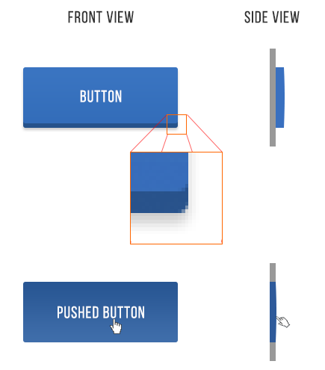

1. Button has a **dark bottom edge** (shadow and the sun doesn’t shine there)
2. Button is **slightly brighter at the top** than the bottom (imitates a slightly curved surface)
3. Button casts a **subtle shadow**
4. Pushed button is **overall darker** - because it’s at the plane of the screen and the sun can’t hit it as easily.

The lesson is to apply these light effects present in the above example to *everything*.

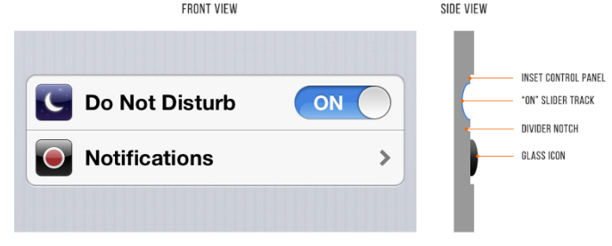

There are **many light effects** going on with these two iOS 6 settings.

* The top lip of the inset control panel casts a small shadow
* The “ON” slider track is also immediately set in a bit
* The “ON” slider track is **concave** and the **bottom reflects more light**
* The icons are set out a bit - look at the bright border around the top of them. This is because the surface is perpendicular to the light source, therefore it receives more light and bouncing a lot of light into your eyes
* The divider notch is shadowed where angled away from the sun and vice versa

Notice that the top of the notch is angled away from the light and is darker while the notch at the bottom is angled towards the light and is brighter.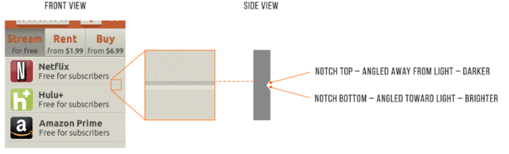

Elements that are generally inset:

* Text input fields
* Pressed buttons
* Slider tracks
* Radio button (unselected)
* Checkboxes

Elements that are generally outset:

* Buttons (unpressed)
* Slider buttons
* Dropdown controls
* Cards
* The button part of a selected radio button
* Popups

Author of article thinks that the trend will move to **semi-flat UI** in the near future. He recommends that readers become proficient in this style. Clean, simple but you’ll have *some* shadows and cues for what to tap/slide/click.

Check out Google’s Material Design Guide (<https://material.io/design/>). It uses ***subtle*** real-world cues to convey information.

1. Black and white first  
   *Designing in grayscale before adding color simplifies the most complex element of visual design - and forces you to focus on spacing and laying out elements*Design **black and white first** - **add color last, and even then, only with purpose**

1. Double your whitespace
2. Learn the methods of overlaying text on images (Part 2)
3. Make text pop - and un-pop (Part 2)
4. Only use good fonts (Part 2)
5. Steal like an artist (Part 2)